Assignment 5

Zend Framework (Web application)

ABSTRACT:

Zend framework is an open source, object oriented web application framework for PHP 5. Zend Framework is often called a ‘Component library’, because it has many loosely coupled components that you can use more or less independently. But Zend Framework also provides an advanced model-view-controller(MVC) implementation that can be used to establish a basic structure for your Zend Framework application.

Functional Requirements and non functional requirements:

1. Options for adapters

2. Handling languages

3. Automatic source detection

4. Routing for translation

5. Combining multiple translation sources

6. Checking for translations

7. Accessing source data

Design Process of Zend Framework:

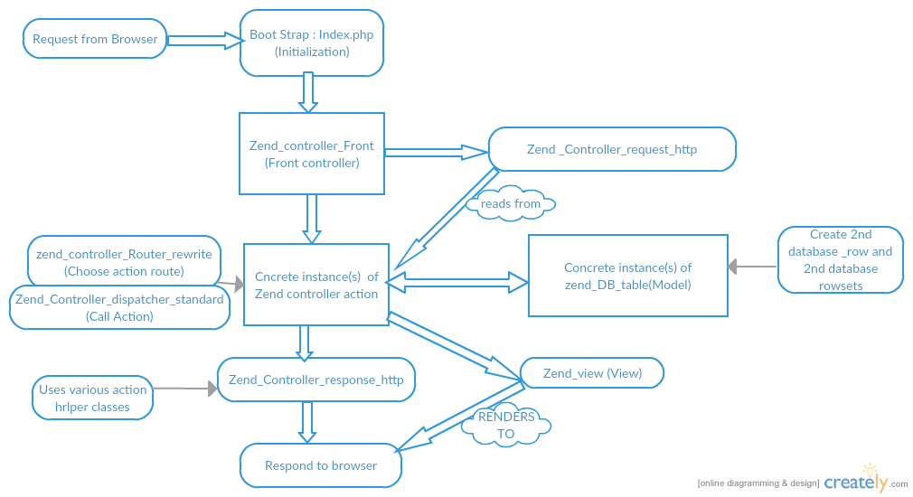

Explanation of Zend Framework:

Zend Framework is a PHP library (collection of classes) and based on MVC (Model-View-Controller).

The Zend_controller family of classes provides a front controller design which dispatches requests to controller actions (Also known as commands) so that all processing is centralized. The controller supports plug-ins at all levels of the process and has built in flex points to enable you to change specific parts of the behavior without having to do too much work.

The view template system is called zend_view which provides a PHP based template system .This means that, unlike smarty.all the view template are written in PHP. Zend_view provides a helper plugin system to allow for creation a fefusable display code.it is designed to allow for overriding for specific requirements.or even replacing entirely with onother template system such as smarty.

Zend_Db_Table implement a table row gateway pattern to form the basis of the model within the MVC system. The model provides the business logic for the application which is usually databsase_based in a web application. Supporting Zebd_Db_Table is Zend_Db which provides object oriented database independent access to a variety of different database, such as Mysql.

Workflow of Zend_Controller:

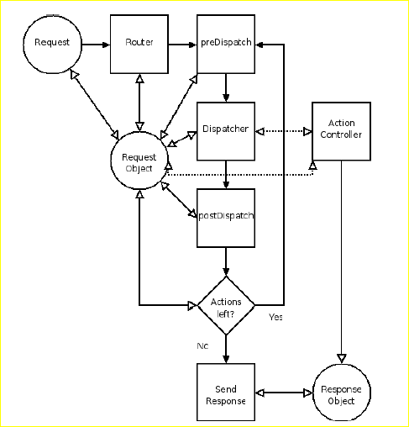

Runflow of zend Framework:

**Adding a database**

use the Zend_DB module to create and manipulate the central database used to store subscription information, as well as saved entries and other information

**The feeds**

Now you add feeds into the equation, enabling the user to create an account, subscribe to particular feeds, and display those feeds. This tutorial uses the Zend_Feed and Zend_Inputfilter modules, the latter used to verify email addresses and to strip HTML tags from feed entries.

**Zend_HTTPClient**

Not all sites have feeds, but it's still useful to track everything in one place. the Zend_HTTPClient module to create a proxy to pull data into the feed-reader interface.

**Creating PDF files**

The Zend_PDF module to enable the user to create a customized PDF of saved articles, images, and search results.

**Sending email**

Using the Zend_Mail module to alert users to new posts and subscribed feeds, and even to send those posts using HTML email.

**Searching**

 Zend_Search module to search existing current and saved blog entries for a particular search term and return ranked results.

**Adding related information and services**

Use the Zend_Service modules to pull in information from other services — specifically, Flickr, Twitter and Yahoo! The interface will use Ajax to pull books, photos, and search results related to a current blog entry or from a search term the user clicks.

**Adding Ajax**

The Zend Framework makes it easy to add Asynchronous JavaScript + XML (Ajax) interactions to your application by automatically translating native PHP objects to and from JavaScript Object Notation (JSON). This article shows how to add this functionality to the feed reader. It also includes a basic description of JSON.

Architecture design Solution:

Real expert advice is very hard to find. Customers asks for ongoing expert advice allowing developers to continuously evolve their skills while focusing on their code and meeting their deadlines. Zend created the architecture advisor program to provide customers with ongoing access to a dedicated PHP architecture from professional services team of expert and extend their outreach to Zend’s wider PHP community and partner ecosystem. Wheather we are starting a new project or improving an existing production application, Zend architecture advisor will be there to assist your team periodically or on demand with software architecture and design ,adoption of development practices and finding solutions to technical challenges.

Alternative Solution:

Zend Framework is using PHP which is more user familiar and to stabilize this it handles databases. Instead of Mysql and sql we can Nosql which is responsive for handling multiple or large data and also we can standardize with using more functionality in the framework. Also we can use API for different protocol and library components.